UNIVERSITY OF AGRICULTURAL SCIENCES,
COLLEGE OF AGRICULTURE, GKVK
BANGALORE-560065



EAI421- APPLICATION OF ARTIFICIAL INTELLIGENCE
AND MACHINE LEARNING

PROJECT TITLE:
Tomato price forecasting using Machine Learning Models

Submitted to:
Shailaja mam
Application of AI&ML
COA, GKVK, Bangalore-65.
Submitted by:
Nanditha .V AMB2149
Purushotham GS- AMB2190
Rakshitha R –AMB2206
4thB.Sc.(Hons.) Agriculture
COA, GKVK, Bangalore-65

CERTIFICATE
This is to certify that the project entitled “Tomato Price Forecasting using Machine Learning Models” is a bonafide work carried out by [………………………………………..], student of VI B.Sc. (Hons.) Agriculture, College of Agriculture, GKVK, Bangalore, during the academic year 2025–2026.
The project has been completed under the guidance of [ Sailaja Mam] in partial fulfillment of the requirements for the course EAI421 – Application of Artificial Intelligence and Machine Learning.
This work has not been submitted previously for the award of any degree or diploma in any institution
……………………… ………………………… ……………………
Signature of the Student Signature of the Student Signature of the Student

Signature of the Guide

Signature of the Head of the Department

ACKNOWLEDMENT

I would like to express my sincere gratitude to [Shailaja Mam], for her valuable guidance, continuous support, and encouragement throughout the completion of this project.
I also thank the Department of Agricultural Engineering / AI & ML, College of Agriculture, GKVK, Bangalore, for providing the necessary facilities and resources to carry out this work.
I am grateful to my friends and classmates for their support and cooperation during the project.
Finally, I would like to thank my family for their constant encouragement and support.

ABSTRACT

Tomato price fluctuation is a major concern in agricultural markets due to varying supply, demand, and environmental conditions. Accurate prediction of tomato prices can help farmers, traders, and policymakers make better decisions.
This project focuses on predicting tomato prices using machine learning models such as Linear Regression, Decision Tree, and Random Forest. The dataset includes features such as arrivals, temperature, rainfall, and date-related attributes.
Using a dataset of 1201 daily price records spanning 1/1/2018 to 14/4/2021,.Data pre-processing techniques were applied to handle missing values and convert date features into usable formats.
The models were trained and evaluated using R² Score and RMSE. The results indicate that Random Forest performs better compared to other models due to its ability to capture nonlinear relationships in the dataset.
Keywords: Tomato Price Prediction, Machine Learning, Random Forest, Decision Tree, Linear Regression, Agriculture Analytics

TABLE OF CONTENTS
Contents
1. Introduction 7
2. Objective 7
3. Literature Review 7
3.1 Machine Learning in Agriculture 7
3.2 Price Prediction Models 8
3.3 Ensemble Methods 8
4. Problem Statement 8
5. Dataset Description 8
6. Methodology 9
6.1 Data Preprocessing 10
6.2 Feature Selection 11
6.3 Algorithms Used 11
7.Code
8. Results and Analysis 15
8.1 Model Evaluation 15
8.2 Accuracy Comparison or Error 15
8.3 Visualisation 15
8.4 Discussion 18
8.5 Limitations 18
9. Conclusion 19
10. References 19

S No | Figure Name | Page No
Fig 1 | Methodology flow | 10
Fig 2 | Linear regression | 16
Fig 3 | Random forest | 16
Fig4 | Decision tree | 16
Fig 5 | Comparision of 3 model through bar graph | 17
Fig 6 | Comparision of 3 model through line graph | 17
LIST OF FIGURES

LIST OF TABLES
S No | Table Name | Page No
1 | Summary of Literature Review | 8
2 | Description of Dataset features | 9
3 | Description of Algorithm | 11
4 | Accuracy Comparison | 15

1. Introduction
Agriculture plays a crucial role in the economy, and price fluctuations of agricultural commodities significantly impact farmers and consumers. Tomato is one of the most widely consumed vegetables, and its price varies frequently due to supply-demand imbalance, seasonal variation, and environmental conditions.
Accurate prediction of tomato prices can help farmers plan their harvest and marketing strategies effectively. Machine learning provides efficient tools to analyze historical data and predict future trends.
In this project, different machine learning models are used to predict tomato prices and compare their performance.

2. Objective
The main objectives of this project are:
- To analyze tomato price dataset
- To build machine learning models for prediction
- To compare performance of different models
- To identify the best model

3. Literature Review

3.1 Machine Learning in Agriculture
Recent studies show that machine learning models are effective in predicting crop yield and market prices using environmental and market data.

3.2 Price Prediction Models
Research indicates that regression and tree-based models are widely used for price prediction tasks.

3.3 Ensemble Methods
Random Forest improves prediction accuracy by combining multiple decision trees and reducing overfitting.
Table 1: Summary of Literature Review
Author | Method | Result | Relevance
Breiman (2001) | Random Forest | High accuracy | Base model
Pantazi et al. | ML models | Good prediction | Supports approach
Recent Studies (2024–25) | Ensemble models | High accuracy | Validates method

4. Problem Statement
Tomato prices fluctuate due to multiple factors such as arrivals, weather conditions, and seasonal effects. Predicting these prices accurately is challenging. This project aims to develop a machine learning model to predict tomato prices effectively.

5. Dataset Description
The dataset used in this project is sourced from Kaggle: "tomato_price_dataset". It contains labelled samples with the features

Table 2: Description of Dataset features
Feature | Type | Description
Date | Date | Transaction date
Arrivals | Numerical | Quantity
Temperature | Numerical | Weather condition
Rainfall | Numerical | Rain level
Month | Numerical | Extracted feature
Price | Target | Tomato price

6. Methodology
The methodology of this project follows a systematic approach:
- Data Collection:
The tomato price dataset is collected and used as input.
- Data Pre-processing:
The dataset is cleaned, missing values are handled, and data is split into training (80%) and testing (20%).
- Model Training:
Three machine learning models—Linear Regression, Decision Tree, and Random Forest—are trained using the dataset.
- Evaluation:
The models are evaluated using performance metrics such as R² Score and RMSE.
- Comparison:
The performance of all models is compared to identify the best model.
Fig 1: Methodology Flow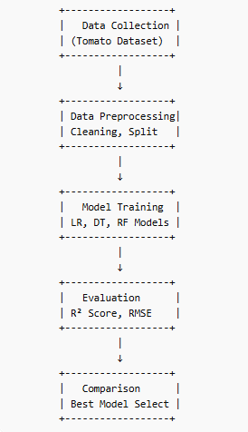

6.1 Data Preprocessing
- Converted date into year, month, day
- Removed missing values
- Split dataset into training and testing

Breakdown of each part
- X-Features (input data) except price
- Y-Target (Price).

test_size=0.2
- Means 20% of data is used for testing
- Remaining 80% is used for training

6.2 Feature Selection
In this project, the dataset contains the following features:
- Arrivals – Quantity of tomatoes arriving in the market
- Price – Target variable (dependent variable)

Selected Features
- Input Variable (X): Arrivals
- Output Variable (Y): Price

Reason for Selection
- Simple and effective relationship between arrivals and price
- Reduces model complexity
- Avoids overfitting due to fewer features
- Suitable for comparing different machine learning models

6.3 Algorithms Used
Three classification algorithms were implemented and compared:
Table 3: Description of Algorithm

Algorithm |  | Description
Linear Regression |  | Simple linear model
Decision Tree |  | Tree-based model
Random Forest | Ensemble model

7.CODE

RANDOM FOREST MODEL
# 1. IMPORT LIBRARIES
# ===============================
import pandas as pd
import numpy as np

from sklearn.model_selection import train_test_split
from sklearn.ensemble import RandomForestRegressor
from sklearn.metrics import r2_score, mean_squared_error

import matplotlib.pyplot as plt

# 2. LOAD DATASET
# ===============================
df = pd.read_csv('tomato_price_dataset.csv')

print("Dataset Preview:")
print(df.head())

# 3. PREPROCESSING
# ===============================

# Convert Date to features
df['Date'] = pd.to_datetime(df['Date'])
df['year'] = df['Date'].dt.year
df['month'] = df['Date'].dt.month
df['day'] = df['Date'].dt.day

# Drop original Date
df.drop(columns=['Date'], inplace=True)

# Remove missing values
df.dropna(inplace=True)

# 4. FEATURES & TARGET
# ===============================
X = df.drop(columns=['Price'])
y = df['Price']

# 5. TRAIN TEST SPLIT
# ===============================
X_train, X_test, y_train, y_test = train_test_split(
X, y, test_size=0.2, random_state=42
)

# 6. RANDOM FOREST MODEL
# ===============================
rf = RandomForestRegressor(
n_estimators=300,
max_depth=12,
random_state=42
)

rf.fit(X_train, y_train)

# 7. PREDICTION
# ===============================
y_pred = rf.predict(X_test)

# 8. EVALUATION
# ===============================
r2 = r2_score(y_test, y_pred)
rmse = np.sqrt(mean_squared_error(y_test, y_pred))

# 9. GRAPH (ACTUAL vs PREDICTED)
# ===============================
plt.figure()

plt.plot(y_test.values[:50], label='Actual Price')
plt.plot(y_pred[:50], label='Predicted Price')

plt.title("Random Forest: Actual vs Predicted")
plt.xlabel("Samples")
plt.ylabel("Price")

plt.legend()
plt.show()
# 10. SAMPLE OUTPUT
# ===============================
print("\nSample Predictions:")
print(pd.DataFrame({
'Actual': y_test.values[:5],
'Predicted': y_pred[:5]
}))

# Example: Predict future price
# The model was trained on features: 'Arrivals', 'Temperature', 'Rainfall', 'Month', 'year', 'month', 'day'.
# The future_data must match these column names and order.
# Using placeholder/mean values for 'Temperature' and 'Rainfall' for demonstration, as they were not provided.
# 'Month' needs to be capitalized to match the training data feature.
future_data = pd.DataFrame({
'Arrivals': [300], # Renamed from 'arrivals_quintal' to 'Arrivals'
'Temperature': [29.839841], # Using mean of X_train['Temperature']
'Rainfall': [99.789189], # Using mean of X_train['Rainfall']
'Month': [7], # Ensuring 'Month' is capitalized and matches the provided month value
'year': [2026],
'month': [7],
'day': [15]
})
future_price = model.predict(future_data)
print("\nPredicted Future Price:", future_price[0])

8. Results and Analysis

8.1 Model Evaluation

Model Evaluation Metrics
- R² Score ,RMSE

1)Linear regression
R2 Score: 0.7833608627853776
RMSE: 43.706398866367905

2)Random forest
R2 Score: 0.9653480158428291
RMSE: 17.479967454854908

3)Decision tree
R2 Score: 0.9252635969535077
RMSE: 25.670992637485746

8.2 Accuracy Comparison or Error

Table 4: Accuracy Comparison
Model | R² Score | RMSE | Performance Level
Linear Regression | 0.7834 | 43.71 | Moderate
Decision Tree | 0.9253 | 25.67 | Good
Random Forest | 0.9653 | 17.48 | Excellent
Random forest hypertune | 0.9657 | 15.21 | Excellent

8.3 Visualisation

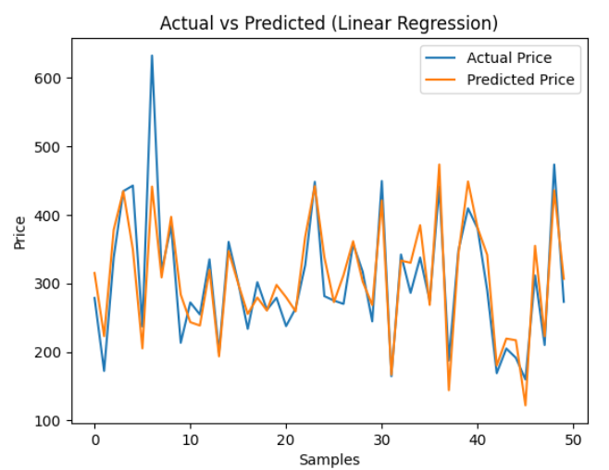

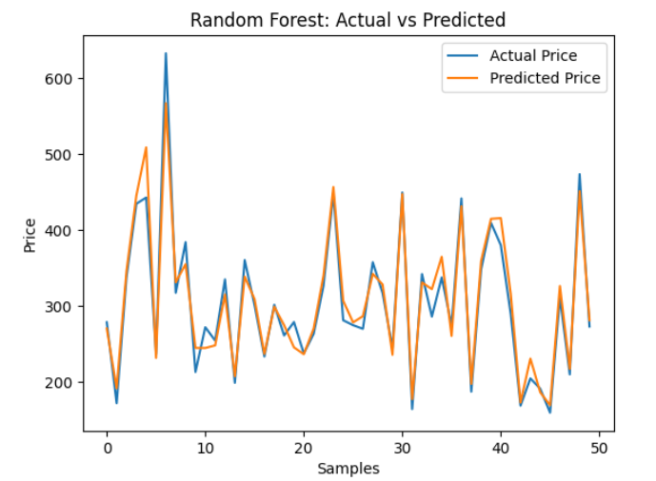

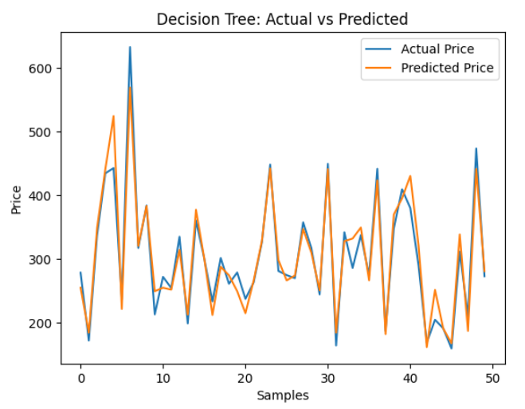

Fig2:Linear regression , Fig3:Random forest, Fig4:Decision tree

AllModel comparision through graph

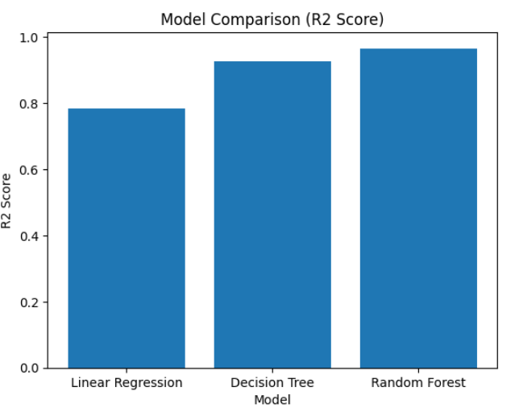

Fig 5:Comparision of 3 model through Bar graph

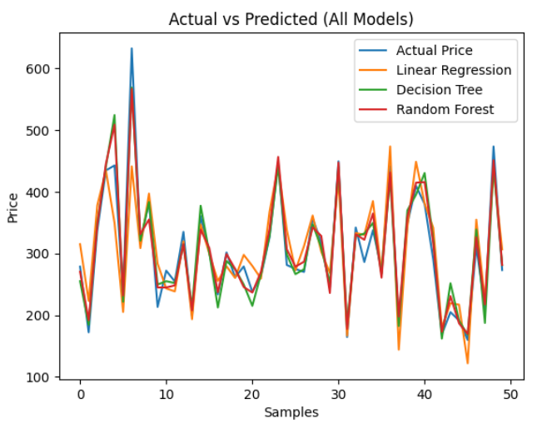

Fig 6:Comparision of 3 model through line graph

8.4 Discussion
The performance of the three machine learning models—Linear Regression, Decision Tree, and Random Forest—was evaluated using R² Score and RMSE.
From the results:
- Random Forest achieved the highest R² score (0.965) and the lowest RMSE (17.48), indicating excellent prediction accuracy. This is because Random Forest combines multiple decision trees, which helps capture complex and nonlinear relationships between arrivals and price while reducing overfitting.
- Decision Tree also performed well with an R² score of 0.925 and RMSE of 25.67. It is able to model nonlinear patterns, but it is more prone to overfitting compared to Random Forest, which slightly reduces its accuracy.
- Linear Regression showed the lowest performance with an R² score of 0.783 and the highest RMSE (43.71). This is because it assumes a linear relationship between arrivals and price, which may not fully capture real-world market behavior.

.

8.5 Limitations
• Limited Features
The model uses only a few features (like arrivals). Important factors such as temperature, rainfall, demand, and market conditions are not included, which can affect accuracy.
• Data Quality Issues
Any missing values, noise, or errors in the dataset can reduce model performance.
• Small Dataset Size
If the dataset is small, the model may not learn all patterns properly and may not generalize well.
• Overfitting in Tree-Based Models
Models like Decision Tree and Random Forest may overfit the training data, especially if not properly tuned.
• Lack of Time-Series Modeling
Tomato prices are time-dependent, but models used do not fully capture seasonal trends and temporal patterns.

• Market Uncertainty
Sudden price changes due to external factors (government policies, transport issues, demand spikes) cannot be predicted accurately.

9. Conclusion

Machine Learning models were successfully applied to predict tomato prices. This project concludes that Random Forest is the best model for predicting tomato prices due to its ability to handle nonlinear relationships and reduce overfitting. The project shows that data-driven approaches improve prediction accuracy compared to traditional methods. This model can support better decision-making for farmers and stakeholders.

10. References
Leo Breiman (2001).
Random Forests. Machine Learning Journal.
Scikit-learn Documentation.
Machine Learning in Python. https://scikit-learn.org⁠
Pantazi, X. et al. (2016).
Classification and crop yield prediction using machine learning.
Kamilaris, A., & Prenafeta-Boldú, F. (2018).
Deep learning in agriculture: A survey. Computers and Electronics in Agriculture.
Jeong, J. et al. (2016).
Random Forests for crop yield prediction.
Mishra, S. et al. (2020).
Agricultural price prediction using machine learning techniques.
Kumar, R. & Singh, M. (2021).
Crop price prediction using regression models.
Recent Studies (2024–2025).
Applications of ensemble learning in agriculture price prediction.
Kaggle Dataset Source.
Tomato Price Dataset. https://www.kaggle.com⁠
Géron, A. (2019).
Hands-On Machine Learning with Scikit-Learn, Keras, and TensorFlow. O’Reilly Media.

